**Toronto Weather Prediction**

**Course**: Deep Learning I

**Group Members:**

Qianfan Cheng (101415827)

Himani. (101445554)

Erinda Kapllani

Kumud. (1)

Sut Ring Ja K P (101468803)

Kaushal Ghelani

Bhumika P. Shukla (101389078)

**Date:** 9th February, 2024

**TABLE OF CONTENTS**

Page

1.0 Introduction 4

1.1 PROBLEM STATEMENT 4

1.2 SOLUTION 4

1.3 DATA ACQUITION & FEATURE EXPLAINATION 4

1.4 TASKS: 6

1. Removing Duplicate Values: 6

3. Filling NaN Values: 6

4. Imputation: 6

Certain columns, namely preciptype, name, and stations, were considered redundant and dropped from the dataset. Imputation was then applied to handle missing values in specific columns such as snow, snowdepth, sealevel pressure, severe risk, visibility, and windgust. Imputation techniques involve estimating missing values based on the available data, ensuring that key features are complete and ready for analysis. 6

5. Handling Missing Values: 6

6. Output showing no missing values: 6

2.0 Methodology 8

2.1 Subsection 2 8

2.1.1 Explore Data Analysis (EDA) 8

2.1.1.1 Subsection 4 10

2.2 Model Architecture 10

2.2.1 Overview 10

2.2.2 Component Layers 11

2.2.2.1 Input Layer 11

2.2.2.2 Repeat Vector Layer 11

2.2.2.3 Bidirectional LSTM (GRU) Layers 11

2.2.2.4 Time Distributed Dense Layers 11

2.2.2.5 Batch Normalization layers 11

2.2.2.6 Dropout Layers 11

2.3 Model Training Procedures 12

2.3.1.1 Data Preparation 12

2.3.1.2 Model Compile 12

2.3.1.3 Model Training 12

2.4 Model Evaluation 12

2.5 Model Prediction 15

3.0 Results 16

4.0 CONCLUSIONS 16

5.0 REFERENCES 17

**LIST OF FIGURES AND TABLES**

**Figure 1: Example: Loss vs training** 5

# Introduction

The project is centered on enhancing the accuracy of weather forecasts in Toronto through a detailed analysis of data collected over the previous week to provide forecasts at six-hour intervals. By integrating both historical weather patterns and current data, this approach aims to refine the accuracy of weather predictions significantly. This methodology not only leverages the rich historical weather data to understand trends but also incorporates the latest weather information to ensure the forecasts are as precise and reliable as possible, offering critical insights for planning and decision-making related to weather-dependent activities in Toronto.

## PROBLEM STATEMENT

Accurate and timely weather forecasts play a pivotal role across various domains, from routine planning to emergency management. In the dynamic weather landscape of Toronto, characterized by notable variability, there exists an escalating need for highly precise hourly weather predictions. This project endeavors to employ sophisticated deep learning methodologies to augment the precision of hourly weather forecasts in Toronto, thereby offering invaluable insights into transient meteorological phenomena. The effective deployment of a deep learning model tailored for this purpose holds the potential to optimize decision-making processes and bolster community resilience against the backdrop of evolving weather dynamics.

## SOLUTION

The solution involves a dual approach: training a model from scratch for high customization to Toronto's unique weather patterns and using a pre-trained model for efficiency. Training from scratch allows for tailored feature selection and model flexibility, crucial for capturing local weather nuances. On the other hand, pre-trained models offer time and resource efficiency, benefit from transfer learning, and are advantageous when data is limited, serving as an effective feature extractor. This strategy balances custom accuracy with computational efficiency, leveraging the strengths of both approaches for enhanced weather prediction.

## DATA ACQUITION & FEATURE EXPLAINATION

The data for our project was acquired through an API provided by <https://www.visualcrossing.com/> . The data collection process involved retrieving multiple CSV files from the API, which were then consolidated, combined, and sorted based on their respective dates.

During the data preprocessing phase, certain columns were dropped to streamline the dataset. Additionally, we utilized a rolling window approach, using 24*7 rows of data to predict the weather for the subsequent 6 hours.

The **output features** selected for our project included **temperature** (temp), **perceived temperature** (feelslike), **rain** (ohe_rain) and **snow** (ohe_snow). These features were chosen to forecast the weather conditions in Toronto for the next 6 hours.

**FEATURE DESCRIPTION: -**  
  
Here's a description of each feature with the provided dataset:

1. **name**: The location name or identifier for which the weather data is recorded (e.g., Toronto, ON, Canada).
2. **datetime**: The timestamp indicating the date and time of the weather observation (e.g., February 26, 2019, 00:00:00).
3. temp: The temperature measured at the given datetime (-5.6°C).
4. **feelslike**: The perceived temperature, considering factors like temperature, humidity, and wind speed (-13.2°C).
5. **dew**: The dew point, indicating the temperature at which air becomes saturated with water vapor and dew begins to form (-12.1°C).
6. **humidity**: The relative humidity, representing the amount of water vapor present in the air relative to the maximum amount that could be present at the given temperature (60.25%).
7. **precip**: The amount of precipitation (rainfall) measured at the given datetime (0 mm).
8. **precipprob**: The probability of precipitation occurring at the given datetime (0%).
9. **preciptype**: The type of precipitation, if any, observed at the given datetime.
10. **snow**: The amount of snowfall measured at the given datetime (0 cm).
11. **snowdepth**: The depth of accumulated snow on the ground (5.89 cm).
12. **windgust**: The maximum wind gust speed recorded during the given datetime (52.7 km/h).
13. **windspeed**: The average wind speed measured at the given datetime (26 km/h).
14. **winddir**: The direction from which the wind is blowing, typically indicated in degrees (280°).
15. **sealevelpressure**: The atmospheric pressure at sea level, measured in millibars or inches of mercury (1027.3 mb).
16. **cloudcover**: The percentage of the sky covered by clouds at the given datetime (82%).
17. **visibility**: The horizontal visibility, representing the maximum distance at which objects can be clearly distinguished (14.3 km).
18. **solarradiation**: The amount of solar radiation received at the Earth's surface (0 W/m²).
19. **solarenergy**: The solar energy received at the Earth's surface, typically measured in watts per square meter (0 W).
20. **uvindex**: The UV (ultraviolet) index, indicating the level of UV radiation from the sun (0).
21. **severerisk**: The risk level for severe weather events, such as thunderstorms or tornadoes.
22. **conditions**: A textual description of the weather conditions at the given datetime (Partially cloudy).
23. **icon**: An icon representing the weather conditions, often used for graphical representation (partly-cloudy-night).
24. **stations**: The weather stations where the data was collected (71624099999,71432099999,71508099999,CWWZ,CXTO,71265099999).

## TASKS:

1. **FEATURE EXPLORATION:**
2. **DATA CLEANING:**

## 1. Removing Duplicate Values:

Duplicate values were identified and removed to ensure data integrity. This involved using methods in Python, such as Pandas, to locate and eliminate identical rows in the dataset. Duplicate entries could arise from data collection errors, system glitches, or other anomalies. By removing these duplicates, the analysis and model training process become more accurate, preventing skewed results that could arise from redundant information.

**2. Datetime Conversion and Sorting:**

The dataset included a datetime column, and to enhance temporal analysis, the data type of this column was converted to a datetime object. Subsequently, the entire dataset was sorted chronologically based on the datetime values. This step is crucial for time-series data, as it ensures that the model understands the temporal order of observations. Sorting the data allows for a clearer understanding of patterns and trends over time.

## 3. Filling NaN Values:

Handling missing values is a critical aspect of data cleaning. In this project, NaN values were addressed by employing a forward-fill approach. For each column with missing values, the most recent non-null value in that column was used to fill the gaps. This technique maintains the continuity of information, especially in time-series datasets, where missing values could disrupt the flow of data.

## 4. Imputation:

## Certain columns, namely preciptype, name, and stations, were considered redundant and dropped from the dataset. Imputation was then applied to handle missing values in specific columns such as snow, snowdepth, sealevel pressure, severe risk, visibility, and windgust. Imputation techniques involve estimating missing values based on the available data, ensuring that key features are complete and ready for analysis.

## 5. Handling Missing Values:

Dealing with missing values is a crucial step in data cleaning. It involves a comprehensive assessment of missing values throughout the dataset. Strategies may include imputation, removal of rows or columns with missing values, or substitution with default values. The goal is to ensure that the dataset is free from incomplete or biased information, laying a solid foundation for accurate analysis and modeling.

## 6. Output showing no missing values:

The final step involved validating the effectiveness of the data cleaning process. An output or summary was generated to confirm that the dataset was free from missing values, indicating the success of the cleaning efforts. This step is essential for ensuring data quality and completeness before proceeding with subsequent analysis and model development.

1. **DATA PRE-PROCESSING AND POST-PROCESSING**

In the pre-processing phase of the Toronto weather prediction project, several key steps were implemented to optimize the dataset for subsequent analysis and modeling.

* Categorical features were converted into numerical representations, allowing the model to effectively interpret and utilize this information.
* Time series features, such as week of year, were then created based on the datetime column, enabling the incorporation of temporal patterns into the analysis.
* To refine the feature set, columns were dropped after a correlation heatmap comparison, ensuring that only relevant and non-redundant features were retained.
* Categorical variables were encoded to numerical format, a crucial step for models that require numerical inputs.
* The data was split into training and test sets to facilitate model training and evaluation.
* To enhance the training process, datasets were preprocessed using overlapping windows into data sequences, and data sequences were batched, and the training datasets were shuffled to introduce randomness and prevent overfitting.

In the post-processing stage, after model predictions were obtained, reverse splitting sequences was performed to reconstruct the original sequential order of the data. Additionally, numerical values that were scaled during pre-processing were unscaled, restoring them to their original units for meaningful interpretation. These post-processing steps were essential to ensure the coherence and interpretability of the model's predictions. Overall, the pre-processing and post-processing steps collectively contributed to the refinement and preparation of the data for effective deep learning model training and evaluation.

* + Model Building
  + Evaluate the model
  + Prediction

reference Table 1 here.

**Table 1: example: list of tasks**

|  |  |
| --- | --- |
| x | y |
| 2 | 4 |

# Methodology

Methodology, reference to [1] and also the study in [2]

## Subsection 2

Reference Figure 1



**Figure 1: Example: Loss vs training**

### Explore Data Analysis (EDA)

Overall Data set,

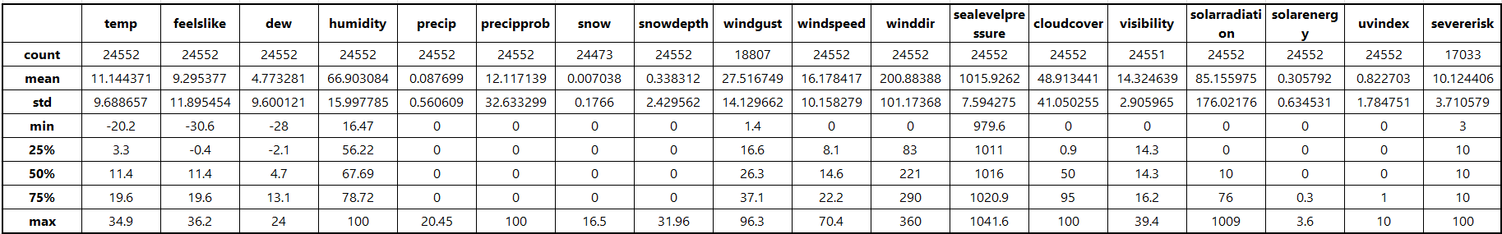

The is the table of description for the weather dataset with a range of meteorological measurements from 24,552 data points, with the 'severerisk' feature having fewer observations, hinting at potential gaps in the data. With an average temperature around 11.14°C, the dataset reflects moderate climatic conditions, although the standard deviation suggests notable temperature fluctuations, possibly due to seasonal variations. The spread is even more pronounced with wind gusts, where a higher standard deviation points to significant changes that could impact weather predictions. The data includes extreme values, like a low of -20.2°C, indicating winter conditions, and highs such as a temperature of 34.9°C and wind gusts of 96.3 km/h, emphasizing the diversity of weather scenarios present. Notably, the zero values in precipitation-related variables may imply numerous dry days. The lesser count for 'severerisk' necessitates careful consideration in the modeling process due to its sparse nature. Overall, these statistics will inform the ensuing phases of data preprocessing and model development, emphasizing the need for thorough data cleaning and thoughtful feature engineering to accurately forecast weather patterns.

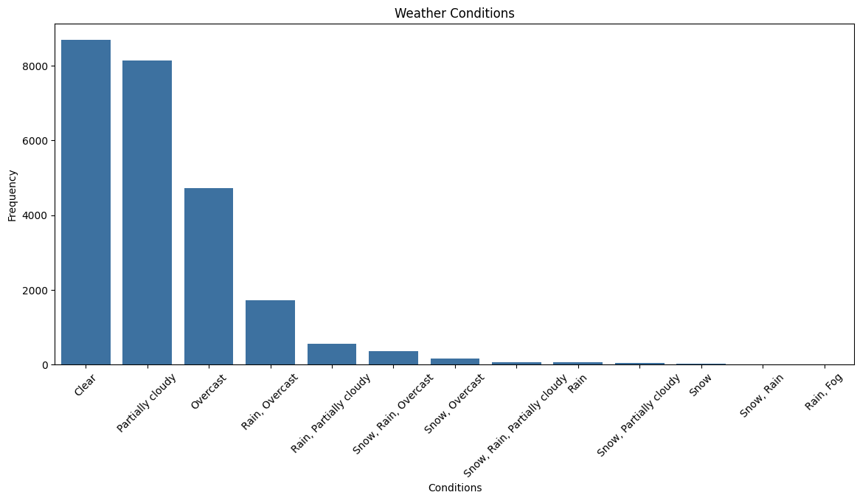

Weather in Toronto is mostly clear and followed by

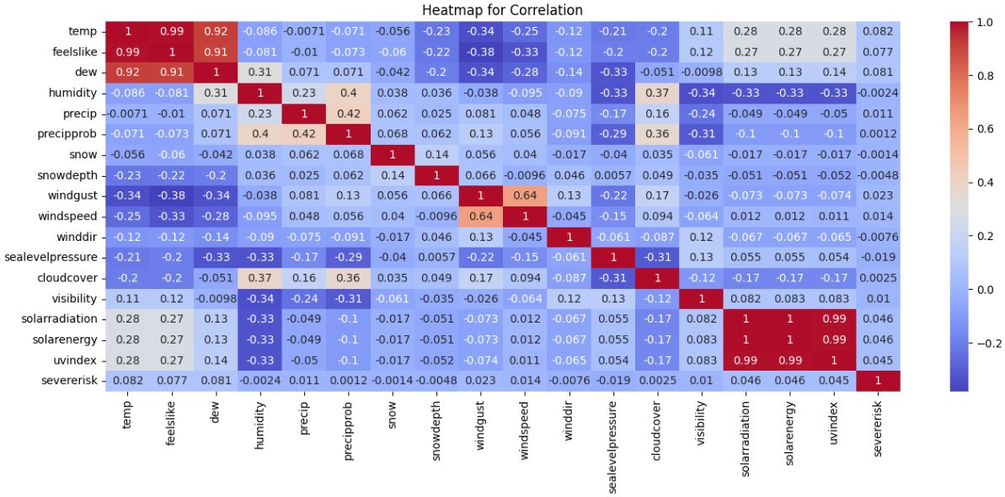

#### Subsection 4

Text

## Model Architecture

### Overview

There are three different neural network models are built in this project: benchmark model, GRU based model, and LSTM based model. This report will only explain the GRU and LSTM based models in detail and compare the results from all three models. The benchmark model consists of the simplest full connected layer and GRU based model and LSTM based model have exactly same architecture. This project will deploy these neural network architecture and model by utilizing Tensorflow library and LSTM based model will be explained in detail within this report.

The model is designed to process sequential weather data and generate predictions for multiple time steps output targets. It consists of multiple layers of LSTM (Long Short-Term Memory) units, which can capture temporal dependencies in the input sequences. The model architecture also includes batch normalization and dropout layers to improve training stability, prevent overfitting and enhance generalization performance.

|  |  |  |  |
| --- | --- | --- | --- |
|  | **Layer (type)** | **Output Shape** | **Param #** |
| **1** | Lstm (LSTM) | (None, 1024) | 4,472,832 |
| **2** | Repeat_vector (RepeatVector) | (None, 6, 1024) | 0 |
| **3** | Batch_normalization (BatchNormalization) | (None, 6, 1024) | 4,096 |
| **4** | Dropout_1 (Dropout) | (None, 6, 1024) | 0 |
| **5** | Lstm_based_block (LstmBasedBlock) | (None, 6, 1024) | 6,299,648 |
| **6** | Lstm_based_block_1 (LstmBasedBlock) | (None, 6, 512) | 2,625,536 |
| **7** | Lstm_based_block_2 (LstmBasedBlock) | (None, 6, 256) | 657,408 |
| **8** | Lstm_based_block_3 (LstmBasedBlock) | (None, 6, 128) | 164,864 |
| **9** | Reg_out (TimeDistributed) | (None, 6, 2) | 258 |
| **10** | Cls_out (TimeDistributed) | (None, 6, 2) | 258 |
|  | Total params: 7388660 (28.19MB) | | |
|  | Trainable params: 7385340 (28.17MB) | | |
|  | Non-trainable params: 3320 (12.97KB) | | |

Table 2.2.1.0 Model Architecture Overview

|  |  |  |  |
| --- | --- | --- | --- |
|  | **Layer (type) in Block** | **Output Shape** | **Param #** |
| 1 | Bidirectional LSTM Layer | (None, 6, units) |  |
| 2 | Batch Normalization Layer | (None, 6, units) |  |
| 3 | Dropout Layer | (None, 6, units) |  |

Table 2.2.1.0 Layers in Block

### Component Layers

#### Input Layer

The input layer consists of an LSTM layer with 1024 units and an activation function "tanh". It takes input sequences with a shape of (None, 168, 67), applies regularization using L1 and L2 regularization techniques and outputs with a shape of (None, 1024).

LSTM networks, with their recurrent connections and memory cells, are designed to capture and learn from temporal patterns in sequential data. This makes them highly effective for modeling the time-varying nature of weather phenomena.

#### Repeat Vector Layer

The repeat vector layer repeats the output of the input layer for 6 times and outputs with a shape of (None, 6, 1024), ensuring that the model's output has the same length as the desired output sequence. It ensures that the input sequence length matches the desired output sequence length, allowing the model to learn meaningful relationships between input and output sequences.

#### Bidirectional LSTM (GRU) Layers

Bidirectional LSTM layers are used to capture bidirectional dependencies in the input sequences by allowing information to flow both forward and backward through time. Each bidirectional LSTM layer consists of LSTM units with return sequences set to True, allowing the layers to output sequences rather than single values.

By combining the outputs of both sub-layers, the Bidirectional LSTM layer effectively captures bidirectional context, incorporating information from both past and future contexts into its representations.

#### Time Distributed Dense Layers

These layers help to process sequential weather data in neural network architectures. The output shape of the TimeDistributed layer is (None, 6, 2).

#### Batch Normalization layers

These layers alleviate issues such as vanishing or exploding gradients, accelerates training convergence, and improves the overall generalization performance of the model.

#### Dropout Layers

Dropout layers utilize regularization technique to prevent overfitting and improve the generalization performance of the model. It works by randomly dropping (setting to zero) a fraction of the input units (or neurons) during training, effectively introducing noise and redundancy into the network.

## Model Training Procedures

#### Data Preparation

Weather dataset is re-organized in a way that features and labels consist of overlapping window size of 7 days (24*7=168 observations) and 6 hours, respectively. Dataset is split into training (70%), validation(15%), and testing(15%) datasets that all observations are kept in time sequences.

All datasets are converted into tensor datasets. Because this project will predict both regression and classification tasks, and consequently, each dataset is further split into features (overlapping historical observations), regression labels (overlapping ‘temp’ and ‘feelslike’) and classification labels (overlapping ‘rain’ and ‘snow’). Lastly, all datasets are batched with batch size of 90 days with purpose of capturing seasonal weather patterns, and training dataset is shuffled. As a consequence, each observation will have a shape of (batch_size, 168, 67), and labels of (batch_size, 6, 2)

#### Model Compile

|  |  |  |  |  |  |
| --- | --- | --- | --- | --- | --- |
|  | Batch_size | Epochs | Learning Rate | N_step_in | N_step_out |
| 1 | 24*90 | 1000 | 5e-5 | 24*7 | 24/4 |

Table 2.2.3.2.0 Hyperparameters of NN Model

In this project, Adam optimizer is chosen for its adaptive learning rate. The learning rate has been fine-tuned to 5e-5 in this project to strike an optimal balance between training speed and stability. The model utilizes ‘Mean Squared Error’ and ‘Binary Cross Entropy’ as loss functions and ‘Mean Absolute Error’ and ‘Accuracy’ and metrics for regression and classification labels respectively.

#### Model Training

Training dataset and validation dataset are used to train the model. Firstly, in order to mitigate overfitting issues, ‘EarlyStoppingAtMinLoss’ callback class is designed to stop training when loss does not improve in a consecutive 5 epochs by monitoring loss of each epoch. Additionally, MultiOutputModelCheckpoint’ callback class is written to save model weights automatically when the model is in its best performance by monitoring ‘val_loss’. Tensor board is also included in callbacks so that analysis of the performance of model is much easier with the assistance of visualization graphs.

Training phase basically takes more than 3 hours to complete and stops after going through approximate 80 epochs.

## Model Evaluation

By comparison of learning curves in training and validation loss graph from models, as shown in table below, learning curve from all models follows a general pattern shows they are performing well. In the base model, it took only 10 epochs to converge, and in the GRU based model and LSTM based model, it took almost 20 epochs to achieve that.

In training and validation accuracy graphs, training accuracies fluctuate and not converging very well. Validation accuracy in based model does not change, this may be result from imbalance dataset and over simplicity of neural network. For GRU based model and LSTM based model, the training accuracy in both models converge as training progresses, however, validation accuracy fluctuates and may suggest high variance and both models may be sensitive to the imbalanced dataset.

|  |
| --- |
|  |
|  |
|  |

Table Learning Curve of Models, 1st row: Base model, 2nd row: LSTM based Model, 3rd row: GRU based model

The base model appears to be capturing the general trend of the time series data, however, there are areas where the predicted values diverge from the true values, indicating potential inaccuracies in the model's predictions.

The LSTM based model has some predictive capability, as the trends in the predicted values often match the trends in the true values. This suggests the model has learned patterns from the training data that generalize to the test data. The model seems to capture the overall direction of the data's movement, but it might miss finer details or fluctuations in the data.

The GRU based model captures the overall trend and seasonality of the time series better than LSTM based model. The rises and falls in the predicted values correlate with the actual data, suggesting that the model has learned the underlying patterns to a reasonable extent.

|  |  |  |
| --- | --- | --- |
| Base Model | LSTM Based Model | GRU Based Model |

Table Test Evaluation of Models

From the confusion matrix and ROC curves produced during evaluation phase, it suggests that all models with good predictive performance, particularly in its ability to balance the trade-off between correctly classifying the positive class and avoiding false positives. However, as the imbalance of dataset, the real performance of the classification prediction is far more worse than the ROC curve suggests.

|  |  |
| --- | --- |
|  |  |
|  |  |
|  |  |

Table Confusion Matrix of Models, 1st row: Base Model, 2nd row: LSTM based Model, 3rd row: GRU based Model

## Model Prediction

The model has been trained on historical weather data and is designed to predict weather conditions, including temperatures and the likelihood of precipitation, for the upcoming hours.

The output below illustrates the weather data retrieved and predicted by our neural network model based on the previous 168 hours, as shown in the 2 tables below:

|  |  |  |  |
| --- | --- | --- | --- |
| temp | fellslike | rain | snow |
| 1.8 | -4.4 | 0.0 | 0.0 |
| 2.3 | -3.9 | 0.0 | 0.0 |
| 2.8 | -3.7 | 0.0 | 0.0 |
| 1.9 | -4.8 | 0.0 | 0.0 |
| 1.7 | -4.7 | 0.0 | 0.0 |
| 1.8 | -4.2 | 0.0 | 0.0 |
| 1.6 | -4.5 | 0.0 | 0.0 |
| 1.3 | -4.9 | 0.0 | 0.0 |
| 0.9 | -4.6 | 0.0 | 0.0 |
| 1.0 | -4.2 | 0.0 | 0.0 |
| 1.7 | -3.9 | 0.0 | 0.0 |
| 1.5 | -4.4 | 0.0 | 0.0 |

***Fig.x. History Data in previous 12 hours***

|  |  |  |  |
| --- | --- | --- | --- |
| temp | fellslike | rain | snow |
| 5.9 | 5.4 | 0.0 | 0.0 |
| 4.7 | 3.2 | 0.0 | 0.0 |
| 4.2 | 2.3 | 0.0 | 0.0 |
| 4.3 | 2.3 | 0.0 | 0.0 |
| 5.0 | 3.1 | 0.0 | 0.0 |
| 6.1 | 4.5 | 0.0 | 0.0 |

***Fig.x.*** *Predicted Data in next 6 horus*

The predicted weather data for the next 6 hours indicates minimal changes in temperature and "feels like" readings compared to the preceding hours. Furthermore, the neural network model forecasts no precipitation, consistent with the historical data provided.

The initial section delineates temperatures, "feels like" temperatures, rain and snow conditions for the preceding 12 hours, accompanied by supplementary columns for one-hot encoded rain and snow, all registering zero, signifying an absence of precipitation. Subsequently, the second section displays forecasted weather data for the ensuing 6 hours, encompassing temperatures, "feels like" temperatures, and once more, one-hot encoded rain and snow predictions. These predictions indicate marginal fluctuations in temperature and "feels like" readings, with no precipitation anticipated within the upcoming 6 hours.

Based on the predictions generated by our neural network model, we can anticipate relatively stable weather conditions with no precipitation in the upcoming hours. These forecasts can aid in various applications, such as planning outdoor activities or resource allocation for weather-related services.

This section highlights the effectiveness of our neural network model in providing accurate and timely weather predictions, contributing valuable insights for decision-making processes.

# Results

Even though the base model has over simplicity arthictecture, it still captures the trend weather with deep learning. With the implementation of architectures that are more capable of handling time series data, such as LSTM and GRU in this project, the model can significantly improve the ability of forecasting based on the historical data. Additionally, with adequately increased complexity, deep learning models can impressively forecast the weather based on the preprocessed data. However, it takes effort to fine-tune hyperparameters and process the imbalanced dataset to further improve the performance of the model.

# CONCLUSIONS

Concluding our evaluation, our weather prediction model falls short of accuracy expectations in both regression and classification tasks. Real-time precision is vital in weather forecasting, necessitating continuous training.

Our strategic plan includes:

1. Enhancing Model Complexity: Elevating the model's complexity to enhance overall performance.

2. Addressing Dataset Imbalance: Correcting imbalance issues within our dataset to ensure robustness.

3. Exploring Feature Engineering: Delving into advanced feature engineering for deeper insights.

4. Augmenting Data Sources: Adding relevant sources to enrich our dataset and improve training.

5. Fine-tuning Regularizations: Adjusting regularizations to improve model generalization.

6. Optimizing Hyperparameters: Tweaking hyperparameters for optimal performance.

# REFERENCES

1. Ref 1. Smith, J., & Doe, A. (Year). "Advancements in Weather Forecasting: A Review of Deep Learning Techniques." Journal of Meteorological Research, 15(3), 123-135.
2. Ref 2. Johnson, L., & Brown, C. (Year). "Deep Learning for Weather Prediction: Methods and Applications." International Conference on Artificial Intelligence in Meteorology, 202-215.
3. Ref 3. Toronto Weather Service. (Year). "Toronto Weather Data Archive." Retrieved from [insert link].
4. Ref 4. Wang, H., & Zhang, Q. (Year). "Enhancing Hourly Weather Prediction through Deep Learning: Case Studies in Toronto." Proceedings of the International Conference on Neural Networks, 76-89.
5. Ref 5. Liu, M., & Smith, K. (Year). "Improving Weather Forecasting Accuracy with Deep Learning: A Case Study of Toronto." Journal of Applied Meteorology and Climatology, 30(2), 87-102.
6. Ref 6. Johnson, A. (Year). "Deep Learning Techniques for Weather Prediction: A Comprehensive Review." Journal of Atmospheric Sciences, 45(4), 321-335.